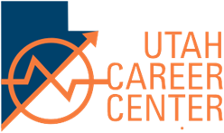
Presented by the
UTAH CAREER CENTER
Certified Rigging Class
Class Dates & Times:
- April 30, 2019, 6:00 pm – 9:00 pm
- May 2, 2019, 6:00 pm – 9:00 pm
- May 7, 2019, 6:00 pm – 9:00 pm
- May 9, 2019, 6:00 pm – 9:00 pm
- May 11, 2019, 6:00 pm – 9:00 pm
- May 14, 2019, 6:00 pm – 9:00 pm
- May 16, 2019, 6:00 pm – 9:00 pm
- May 18, 2019, 8:00 am – 3:30 pm
- May 21, 2019, 6:00 pm- 9:00 pm
- May 23, 2019, 6:00 pm- 9:00 pm
- May 25, 2019, 8:00 am- 3:30 pm
Test Date & Time:
- May 18, 2019 Crane Practical Test Day
- May 23, 2019 Written Test Day
- May 25, 2019 Crane Practical if needed
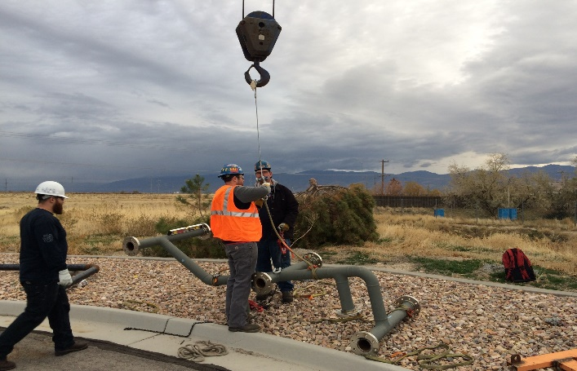

Utah Career Center
640 North Billy Mitchell Road
Salt Lake City, Utah 84116

If you plan to attend this certification class, please contact the Utah Career Center at (801)295-6198
Registration Closing:
April 15, 2019
Register By calling: (801)295-6198
